MYUNG JIN SHIPPING CO., LTD.
RM 301, 988-5, GOHYUN DONG, GEOJE, GYEONG NAM, KOREA
FLAT BARGE ‘ POS 25000’
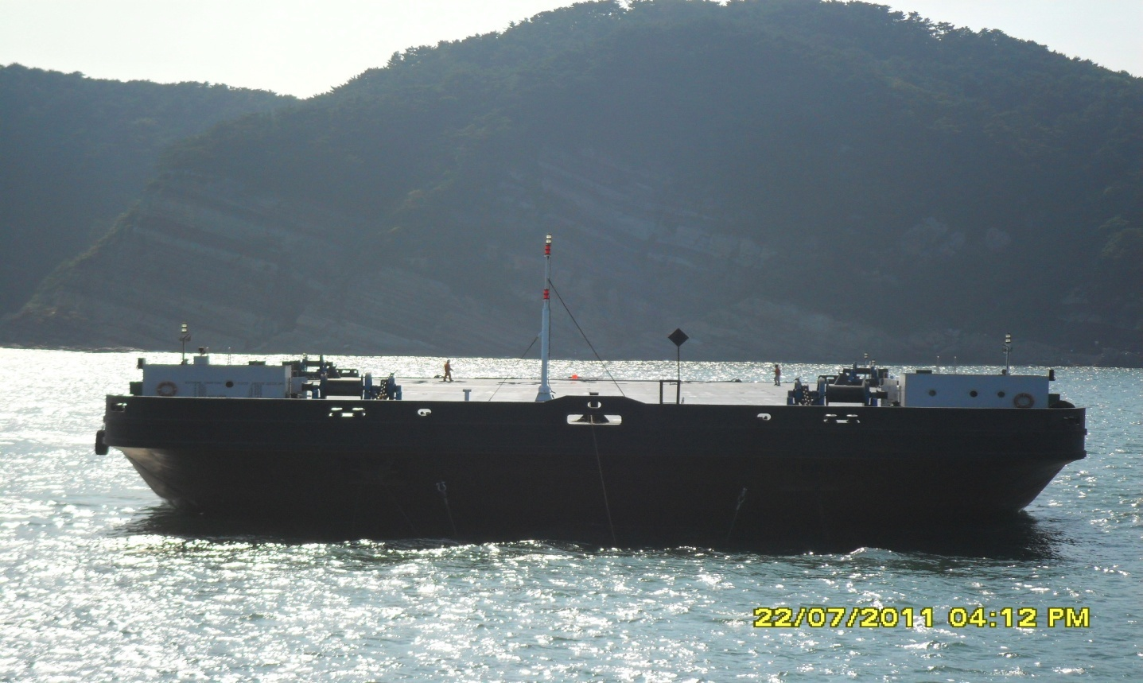

GENERAL
Vessel’s name | POS 25000
Builder | ForceTEC Corporation
Year Built | APRIL 2009
Type | Flat Barge
Classification Society | K.R(Class No. 0966705)
Flag | KOREA
IMO NO /Official NO / Call Sign | - / MSB-097157 / -
Navigation Area | Great Coastal
DIMENSIONS
LOA | 95.04 M
Breadth (MLD) | 36.00 M
Depth (MLD) | 6.50 M
GRT / NRT | 6,190T / 1,857T
Dead Weight | 12,500T
Tank Capacity
IFO | -
MGO | 12.0 k/l
L.O
Ballast Capacity | 2,000㎥/hr x 3EA = 6,000㎥/hr
Fresh Water
PERFORMANCE
E/R MACHINERY
Main Generator Engine Power |  | 504KW * 1 Set
Aux’ Generator Engine Power |  | 24KW * 1Set
G.S & Fire Pump Capacity |  | 90㎥/hr * 1Set
BILGE & G.S Pump Capacity |  | 90㎥/hr * 1Set
Ventilation Fan |  | 2 set
F.W PUMP |  | 1 SET (HANIL)
Oily Water Separator |  | 1Set (1㎥/hr * 15ppm)
Deck Machinery
Anchor & Chan |  | 3,540Kg * 54￠*9Shot * 2Set
Windless |  | 9m / min * 13.0Ton 2Set
Windless Hyd. Pump * Motor |  | 440V * 60Hz * 37.0 Kw
MOORING WINCH |  | 2 Set(10M/min * 6.0 TON)
Communication
HAND V.H.F |  | ICOM * 2Set

Particulars are given entirely without warranty as to correctness and interested parties must satisfy themselves by inspection of the vessel.

