MYUNG JIN SHIPPING CO., LTD.

“ M Y U N G J I N 9 0 0 3 ”
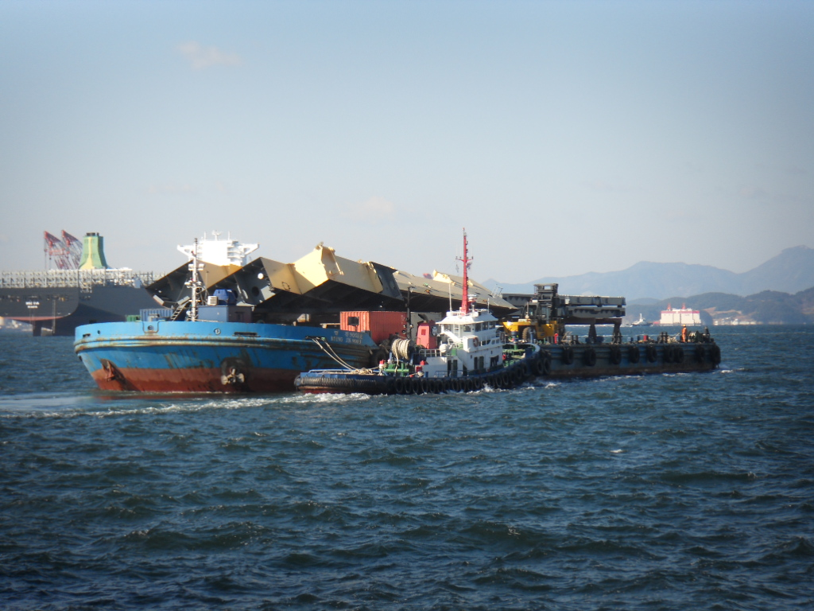

GENERAL
VESSEL’S NAME | MYUNGJIN 9003
BUILDER | KASTEC.CO.LTD.
YEAR BUILT | 2003. 01. 01.
TYPE | BARGE
CLASSIFICATION SOCIEAT | KR
FLAG | KOREA
IMO NO /Official NO | NIL / BSB-030098
NAVIGATION AREA | GREAT COASTAL
DIMENSIONS
LOA | 77.5 m
Breadth (MLD) | 25.0 m
Depth (MLD) | 5.00 m
DEAD TON | 5,508 TON
GRO TON | 2,490 TON
SPEED
Tank Capacity
F.O | ABT’ 6,000 ℓ
L.O | ABT’ 400 ℓ
Ballast Capacity | 6,200 TON (100% FULL)
Heeling Capacity | 630 TON (100% FULL)
PERFORMANCE
E/R MACHINERY
MAIN GENERATOR ENGINE | 336 HP X 1800 RPM X 224 KW
ENGINE TYPE / MODEL | DOOSAN / AD126TI
D.O CONSUMPTION | 20 ℓ/HR
PORT GENERATOR ENGINE | 46 HP X 1800 RPM X 34 KW
ENGINE TYPE / MODEL | ISUZU / TWY20D
D.O CONSUMPTION
BALLAST & HEELING PUMP | 1,000 TON/HR X 12 M X 75 KW X 2
FIRE / BILGE PUMP | 40 TON/HR X 20 M X 7.5 KW
BILGE / G.S PUMP | NIL
O.W SEPARATOR | NIL
DECK MACHINERY
WINDLASS | 8 TON X 10 M/MIN
MOORING WINCH | 5 TON X 12 M/MIN
BOWER ANCHOR | 2,560 KG (STOCKLESS)
ANCHOR CHAIN | 42 ø X 412.5 M (G2, STUD CHAIN)
Communication
VHF(DSC) * 2SET

Particulars are given entirely without warranty as to correctness and interested parties must satisfy themselves by inspection of the vessel.

