
“명진 801 호 (TUG BOAT)”
MYUNG JIN SHIPPING CO., LTD.
RM. 801, MYUNGJIN BLDG., 183, HASINBEONYEONG-RO, SAHA-GU, BUSAN, KOREA

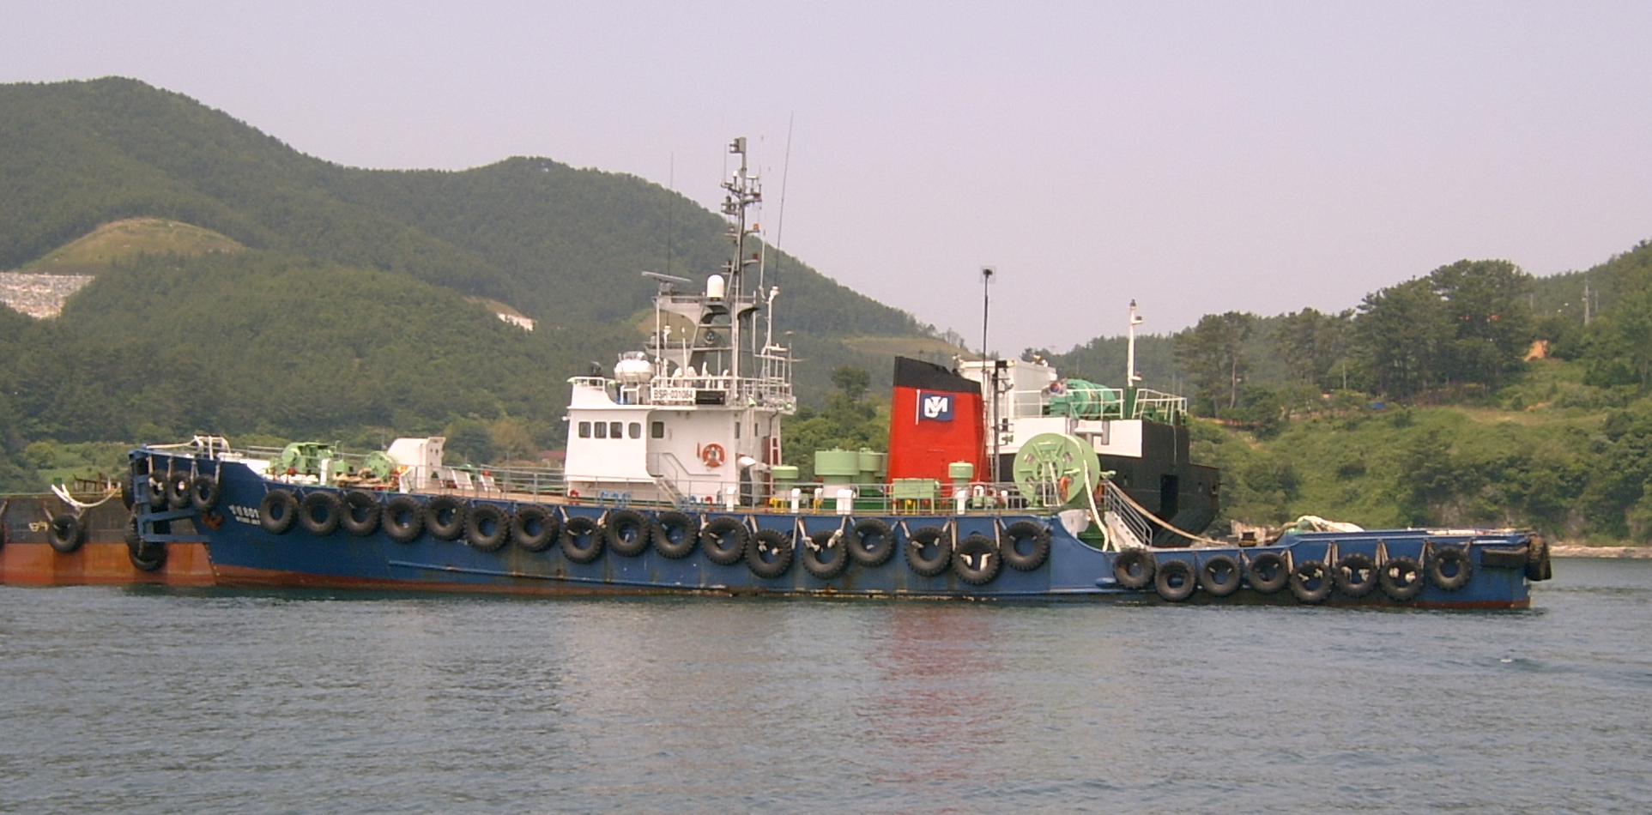

주요 선박제원(PRINCIPAL PARTICULARS)
. 선 명(SHIP/S NAME) : MYUNG JIN 801
. 선박번호 (REG. NO) : BSR – 031084
. 총 톤 수 (GROSS TONNAGE) : 228 GRT
. 신호부자 (CALL SIGN) : DSOZ9
. 선체치수 (HULL DEMENSION)
선 장 (LENGH : O.A) : 43.18M
선 폭 (BREADTH : MLD) : 7.00M
선 심 (DEPTH : MLD) : 3.61M
. 건조장소 (YARD) : 일본 북해도 유기조선㈜
. 건조일자 (YEAR BUILT) :1978,11
. 선 적 항 (PORT OF REGISTRY) : BUSAN
. 항 해 구 역 (NAVIGATION AREA) : 근해(Greater coastal)
. CLASSIFICATION : K. S. T
. 선 종(TYPE OF SHIP) : TUG BOAT
. 평균속력(MEAN SPEED) : 9~10Kt (부선예인시)
기 관 및 기 기 류

- MAIN ENGINE : 2SET
MAKER : DAIHATSU
TYPE : 6DSM-28S(L)
B H P : 1600HP x 2SET
R P M : 720
ENG’ NO : D628073, D628074
CLUTCH TYPE : DR2A-22D(L) (2SET)
CLUTCH RATIO : 1) 저속 2.441 : 1
2) 고속 1.729 : 1
3) 역전 1.610 : 1
CLUCH NO : 222002D, 222003D
TURBO-CHAGER : VTR-251ZN
GOVERNOR TYPE : RHD-6형
- GENERATOR DIESEL ENGINE

NO,1 GENERATOR
MAKER : VOLVO PENTA
MODEL : TMD 100AK
B H P : 184PS
GENERATOR : 225V x 60㎐ x 155KVAx 1800RPM
GEN’ MODEL : NV 5026-4 (TAIYO ELECTRIC MFG CO, LTD)

NO,2 GENERATOR
MAKER : VOLVO PENTA
MODEL : TMD 100AK
B H P : 184PS
GENERATOR : 225V x 60㎐ x 155KVAx 1800RPM
GEN’ MODEL : NV 5026-4 (TAIYO ELECTRIC MFG CO, LTD)

NO,3 GENERATOR
MAKER : VOLVO PENTA
MODEL : MD 100BK
B H P : 94PS
GENERATOR : 225V x 60㎐ x 75KVAx 1800RPM
GEN’ MODEL : NV 5016-4 (TAIYO ELECTRIC MFG CO, LTD)
- 각종보조기기
1. 갑판보기
  - WINDLASS : 1SET
MAKER : 천기(KAWASAKI) 중공업
TYPE : ID-180L
CAPACITY : 4TON x 15m/min
HYD’ PUMP : QT52-50S
MOTOR : 220V x 60㎐ x 30㎾ x 1750 RPM
ANCHOR & CHAIN : 470Kg x 28Ø x 8SHOT x 2SET
2) CAPSTAN : 1SET
MAKER : 천기(KAWASAKI) 중공업
TYPE : ID-180M
CAPACITY : 3TON x 15m/min
HYD’ PUMP : QT43-31.5S
MOTOR : 220V x 60㎐ x 22㎾ x 1750 RPM
- 예인 ROPE WINDING 감속기
MAKER : 협성선박 공업사
B H P :
4.기관보기
- STEERING GEAR
MAKER : KAWASAKI HEAVY INDUSTRIES,LTD
TYPE : RZ-125E
MOTOR NO : 909Z227S 1/2
PUMP NO : S-339178
SERIAL NO : 42E3913 1/2
- NO,1 M/E COOLING WATER PUMP
MAKER : ASAHI ELECTRIC
MOTOR : 220V x 60㎐ x 3.7㎾ x 4P
SERIAL NO : 014898
3) NO,2 M/E COOLING WATER PUMP
MAKER : ASAHI ELECTRIC
MOTOR : 220V x 60㎐ x 3.7㎾ x 4P
SERIAL NO : 264250230
- NO,1 G/S & BALLAST PUMP
MAKER : ASAHI ELECTRIC
MOTOR : 220V x 60㎐ x 5.5㎾ x 4P
SERIAL NO : 88541538
5) NO,1 G/S & BALLAST PUMP
MAKER : ASAHI ELECTRIC
MOTOR : 220V x 60㎐ x 2.2㎾ x 4P
SERIAL NO : 154169
6) M/E L.O PRIMING PUMP
MAKER : ASAHI ELECTRIC
MOTOR : 220V x 60㎐ x 5.5㎾ x 6P
SERIAL NO : 88590269
7) M/E F.O BOOST PUMP
MAKER : ASAHI ELECTRIC
MOTOR : 220V x 60㎐ x 2.2㎾ x 6P
SERIAL NO : 48896
8) N0,1 M/E NOZZLE COOLING WATER PUMP
MAKER : ASAHI ELECTRIC
MOTOR : 220V x 60㎐ x 0.4㎾ x 4P
SERIAL NO : 8121461018
9) N0,2 M/E NOZZLE COOLING WATER PUMP
MAKER : ASAHI ELECTRIC
MOTOR : 220V x 60㎐ x 0.4㎾ x 4P
SERIAL NO : 8121461019
10) NO,1 STEERING GEAR HYDRAULIC PUMP
MAKER : ASAHI ELECTRIC
MOTOR : 220V x 60㎐ x 3.7㎾ x 4P
SERIAL NO : 50786
11) NO,2 STEERING GEAR HYDRAULIC PUMP
MAKER : ASAHI ELECTRIC
MOTOR : 220V x 60㎐ x 3.7㎾ x 4P
SERIAL NO : 50787
12) E/R 통풍기
MAKER : ASAHI ELECTRIC
MOTOR : 220V x 60㎐ x 2.2㎾ x 4P
SERIAL NO :
13) 선원실 통풍기
MAKER : ASAHI ELECTRIC
MOTOR : 220V x 60㎐ x 2.2㎾ x 4P
SERIAL NO :
14) AIR COMPRESSOR
MAKER : ASAHI ELECTRIC
MOTOR : 220V x 60㎐ x 7.5㎾ x 4P
SERIAL NO :
15) 유수분리기 : 1SET
3. 항해 및 통신장비
1) RADER : 2SET
2) SSB : 1SET
3) VHF : 1SET
4) 조타기 STAND 및 CPP CONTROL STAND
5) NAVITAX : 1SET
6) AMP : 2SET
7) RPM INDICATOR : 1SET
8) PITCH INDICATOR : 1SET
9) 기타 근해구역 조건에 맞도록 설치되어 있음

