MYUNG JIN SHIPPING CO., LTD.
RM 301, 988-5, GOHYUN DONG, GEOJE, GYEONG NAM, KOREA

FLAT BARGE ‘ MYUNGJIN 20002’
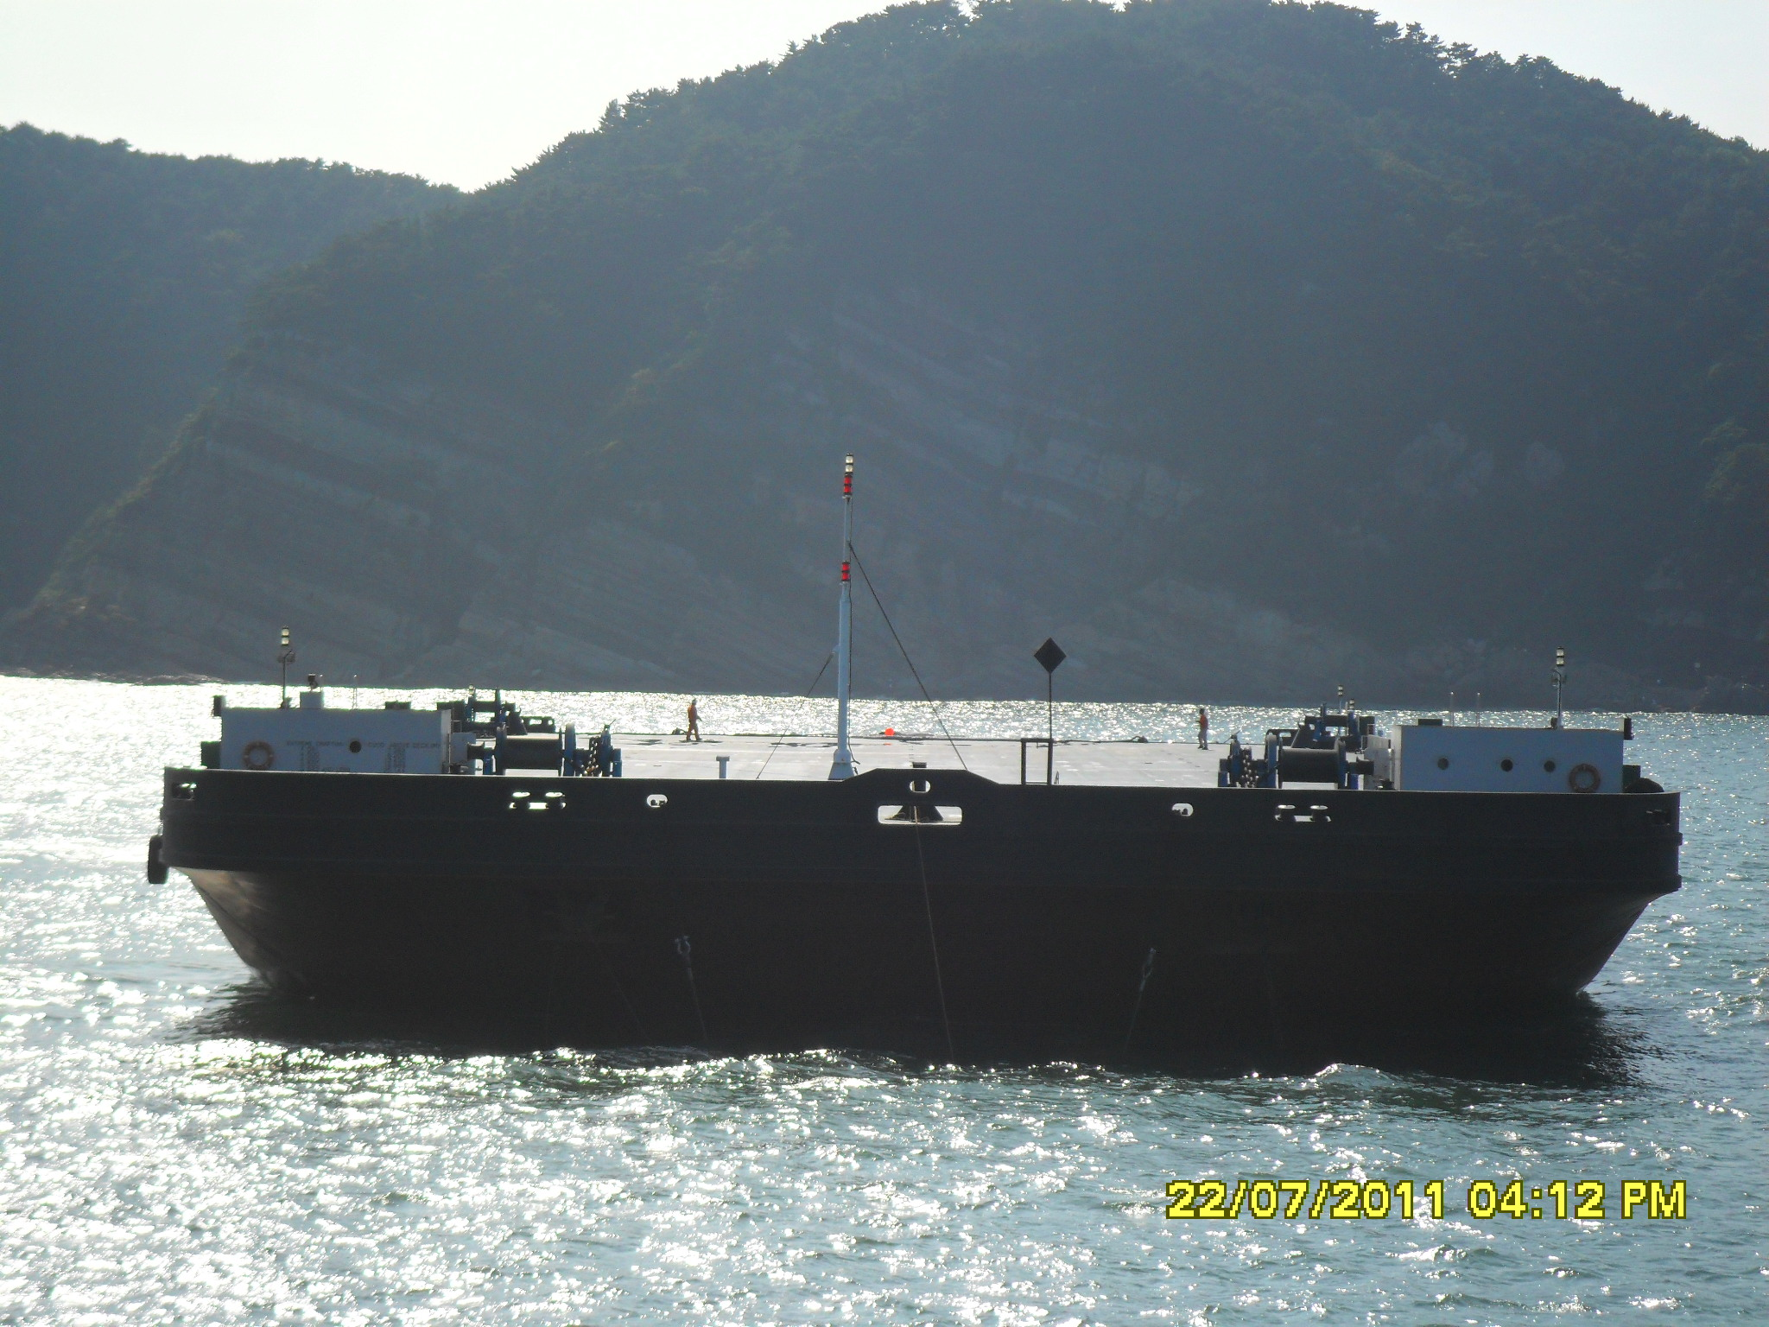

GENERAL
Vessel’s name | MYUNG JIN 20002
Builder | TONGDE SHIPYARD
Year Built | Jan. 2010
Type | Flat Barge
Classification Society | K.R(Class No. 1072807)
Flag | KOREA
IMO NO /Official NO / Call Sign | - / BSB-110086 / -
Navigation Area | Great Coastal
DIMENSIONS
LOA | 92.50 M
Breadth (MLD) | 36.00 M
Depth (MLD) | 5.80 M
GRT / NRT | 5,103T / 1,530T
Dead Weight | 12,000T
Tank Capacity
IFO | -
MGO | 7.0 k/l
L.O
Ballast Capacity | 9,630 Ton
Fresh Water
PERFORMANCE
E/R MACHINERY
Main Generator Engine Power |  | 265KW * 1 Set
Engine Type / Builder |  | D9A2MG / VOLVO
Aux’ Generator Engine Power |  | 24KW * 1Set
Engine Type / Builder |  | EM68 / HYUNDAI
Ballast Pump |  | PUMPQUIP / 250MC
Capacity |  | 1,000m3 /h * 2 Set
G.S & Fire Pump |  | DESMI / S100-80-175N/A09
Capacity |  | 90 m3 / h * 1Set
BILGE & G.S Pump |  | DESMI / S100-80-175N/A09
Capacity |  | 90m3 / h * 1SET
Ventilation Fan |  | 2 set
F.W PUMP |  | 1 SET(HANIL)
Oily Water Separator |  | 1Set(Bilgemoo, 1.5Kw * 15ppm)
Electric Welding Machine |  | 500A * 1 Set
Deck Machinery
Anchor & Chan |  | 3,540Kg * 54￠*9Shot * 2Set
Windless |  | 9m / min * 13.0Ton 2Set
Windless Hyd. Pump * Motor |  | 440V * 60Hz * 37.0 Kw
MOORING WINCH |  | 2 Set(10M/min * 6.0 TON)
Communication
HAND V.H.F |  | ICOM * 2Set

Particulars are given entirely without warranty as to correctness and interested parties must satisfy themselves by inspection of the vessel.

