
MYUNG JIN SHIPPING CO., LTD.
RM. 801, MYUNGJIN BLDG., 183, HASINBEONYEONG-RO, SAHA-GU, BUSAN, KOREA
TUG BOAT ‘ CHU JIN ’
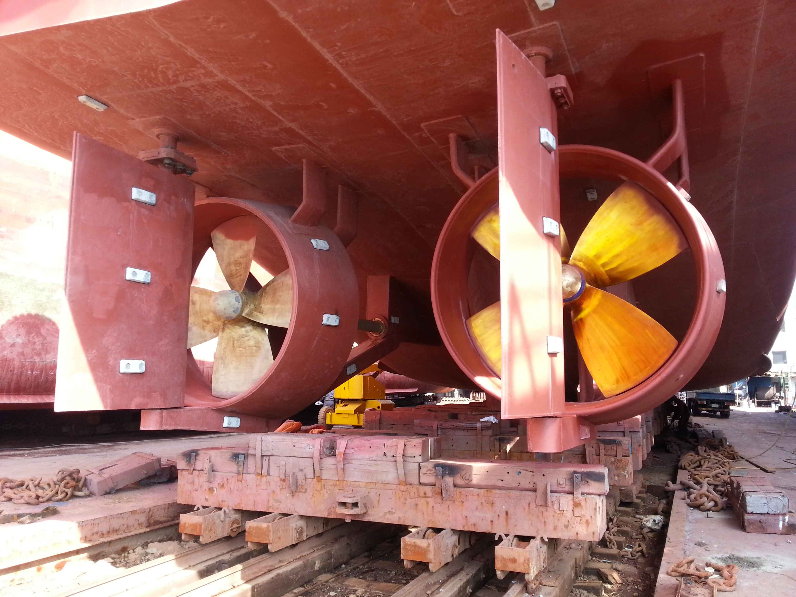

GENERAL
VESSEL’S NAME | CHU JIN
BUILDER | DANDONG CHANG HAI SHIPPING
YEAR BUILT | 06th OCT. 1999
TYPE | TUG BOAT
CLASSIFICATION SOCIEAT | RINA / KST
FLAG | KOREA
IMO NO /Official NO / Call Sign | 8746430 / BSR-101001 / DSRA6
NAVIGATION AREA | GREAT COASTAL
DIMENSIONS
LOA | 40.49 M
Breadth (MLD) | 10.80 M
Depth (MLD) | 4.80 M
GRT / ITC | 322.0 TON / 496.0
NET TON
BOLLARD PULL | 47.0 TON
Tank Capacity
FO(B-A) | 307.00 K/L
MGO | 50.00 K/L
LUB. OIL | 10.00 K/L
Ballast Capacity
Fresh Water | 200 TON
PERFORMANCE
E/R MACHINERY
MAIN ENGINE |  | 2,000 PS * 320RPM * 2 SET
ENGINE TYPE / MODEL |  | 6LUD35 / HANSHIN DIESEL
F.O CONSUMPTION |  | 400 ℓ/ h
MAIN GENERATOR ENGINE |  | 300PS * 1,200RPM * 2 SET
ENGINE TYPE / MODEL |  | 6RAL-T / YANMAR DIESEL
D.O CONSUMPTION |  | 30 ℓ/ h
PORT GENERATOR ENGINE |  | 80PS(80KW) * 1,200RPM *1 SET
ENGINE TYPE / MODEL |  | AD136T / YANMAR DIESEL
D.O CONSUMPTION |  | 15 ℓ/ h
CLUTCH |  | REDUCTION GEAR
PROPELLER |  | FPP
DECK MACHINERY
ROPE TOWING WINCH |  | 300M * 110￠
WIRE TOWING WINCH |  | 500M * 50￠
Communication
VHF(DSC) * 2SET |  | WEATHER FAX * 1SET
AIS * 1SET |  | INMARSAT-C(INCUL. LRIT) * 1SET
RADAR(ALPHA) * 2SET |  | SSB / DSC * 1SET
EPIRB * 1SET |  | TWO-WAY VHF * 2SET
GPS PLOTER * 2SET |  | RADAR TRANSPONDER * 1SET
MAGNETIC COMPASS * 1SET |  | Echo Sounder/Speed Log *1SET
MF/HF(DSC, NBDP) * 1SET |  | FIRE DETECTOR * 1SET

Particulars are given entirely without warranty as to correctness and interested parties must satisfy themselves by inspection of the vessel.

