MYUNG JIN SHIPPING CO., LTD.
RM 301, 988-5, GOHYUN DONG, GEOJE, GYEONG NAM, KOREA
FLAT BARGE ‘ JNK B002
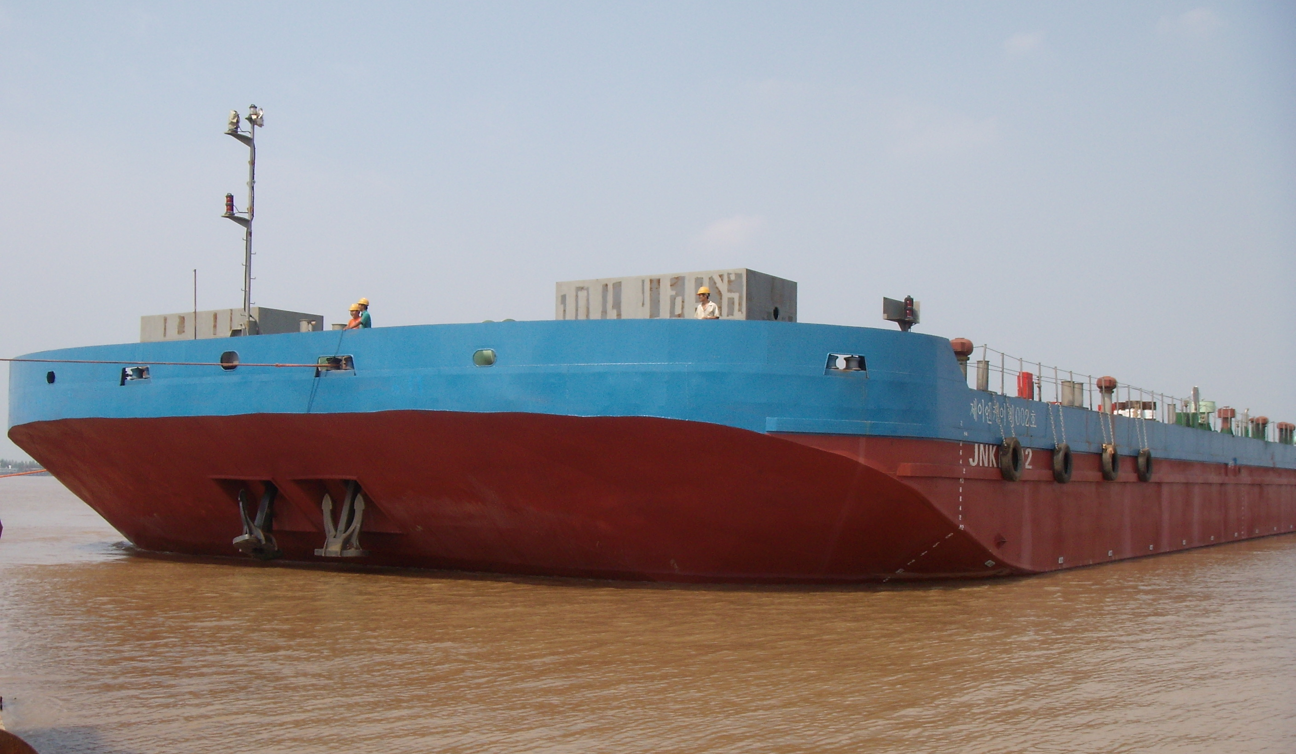

GENERAL
Vessel’s name | JNK B002
Builder | ZHENJIANG YONG’AN
Year Built | 2007.08.07
Type | Flat Barge
Classification Society | K.R(Class No. 0762619)
Flag | KOREA
IMO NO /Official NO / Call Sign | - / BSB-071182 / -
Navigation Area | Great Coastal
DIMENSIONS
LOA /Length | 83.0M / -M
Breadth (MLD) | 28.0 M
Depth (MLD) | 5.00 M
GRT / NRT | 3,036T / 910T
Dead Weight | 6,900T
Tank Capacity
IFO | ABT’ 5000 ℓ
MGO | 12.0 k/l
L.O | ABT’ 300 ℓ
Ballast Capacity | 5,974 Ton (100% FULL)
Heeling Capacity | 854 Ton (100% FULL)
Fresh Water | ABT’3000ℓ
PERFORMANCE
E/R MACHINERY
Main Generator Engine Power |  | 336BHP * 1800RPM
Engine Type / Builder |  | / DOOSAN
PORT Generator Engine |  | 73HP * 1800RPM * 24KW
Ballast Pump |  | 1,500TON/HR * 10M
G.S & Fire Pump |  | 1,75RPM *90M *22KW
BILGE PUMP |  | 1M³/HR * 20M *0.4KW
Deck Machinery
Windless |  | 11TON 9M / min *1Set
Windless Hyd. Pump * Motor |  | 2 Set
MOORING WINCH |  | 2 Set(10M/min * 6.0 TON) * 2 SET
BOWER ANCHOR |  | 2,505 KG (STOCKLESS)
Anchor & Chan |  | 42￠*200M (G2, STUD CHAIN)
Communication
HAND V.H.F |  | ICOM * 2Set

Particulars are given entirely without warranty as to correctness and interested parties must satisfy themselves by inspection of the vessel.

